Project Design Phase - I Solution Architecture

|  |  |
| --- | --- |
| **DATE** | **19 OCTOBER 2022** |
| **TEAM ID** | **PNT2022TMID14113** |
| **PROJECT NAME** | **IOT BASED SMART CROP PROTECTION FOR AGRICULTURE** |
| **MAXIMUM MARKS** | **4 MARKS** |

|  |
| --- |
|  |

# SENSORS

The soil moisture sensor senses the moisture level in the soil. The humidity and temperature sensor gives the humidity and temperature values of the atmosphere which determine whether the crop is suitable for growth. The soil moisture sensor, humidity and temperature sensor continuously monitors the soil and environmental conditions, sends the live data to mobile.

# ARDUINO UNO

Arduino Uno is the heart of the system. The facts gathered with the aid of the sensors are sent to the Arduino UNO. The gathered information may be displayed in a Arduino IDE.

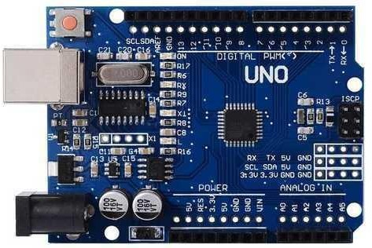

# SOIL MOISTURE SENSOR

A soil moisture sensor empowers agriculturalists to estimate the water levels without the need to be physically present in the field.

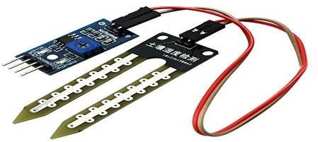

# HUMIDITY SENSOR

Humidity sensors are electronic devices that measure and report the moisture and air temperature of the surrounding environment.

1. The different soil parameters (temperature, humidity, Soil Moisture) are sensed using different sensors, and the obtained value is stored in the IBM cloud.
2. Arduino UNO is used as a processing unit that processes the data obtained from sensors and weather data from weather API.
3. Node-red is used as a programming tool to wire the hardware, software, and APIs. The MQTT protocol is followed for communication.
4. All the collected data are provided to the user through a mobile application that was developed using the MIT app inventor. The user could make a decision through an app, whether to water the crop or not depending upon the sensor values. By using the app they can remotely operate the motor switch.

# NODE-RED

# Node-RED is a programming tool for wiring together hardware devices, APIs and online services. Primarily, it is a visual tool designed for the Internet of Things, but it can also be used for other applications to very quickly assemble flows of various services.